**CI/CD Pipeline set up**

# **Document Control**

## **Purpose of this Document**

The purpose of this document is to provide detail information to set up CI/CD pipeline for he Vehicle Registration API.

# **Vehicle Registration API Deployment**

There are 3 main steps include in setting up CI/CD pipeline in Azure DevOps.

Step 1: Import a Git repo

Step 2: Create a Pipeline

Step 3: Create a Release pipeline

## **2.1 Import a Git repo:**

Prerequisite: The user should have the access to Azure DevOps.

* Go to Azure DevOps

**Import into new repo:**

* Click on Repo on the left-hand side tab.

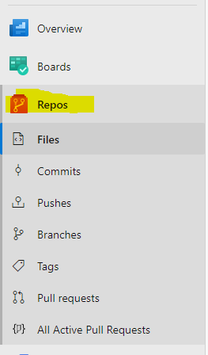

* From the repo drop-down, select **Import repository**.
* If the source repo is publicly available, just enter the clone URL of the source repository and a name for your new Git repository.

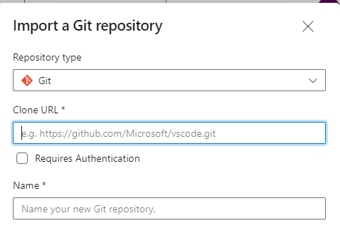

This will successfully import the repository into Azure DevOps.

## **2.2 Create a Pipeline:**

Once the repo has been imported successfully. We need to create a pipeline.

Select Pipeline from the left hand side tab.

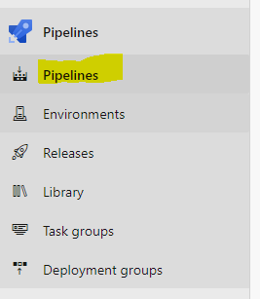

Click on the New pipeline on the right corner

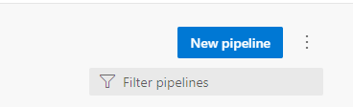

Configure the repo to the new pipeline

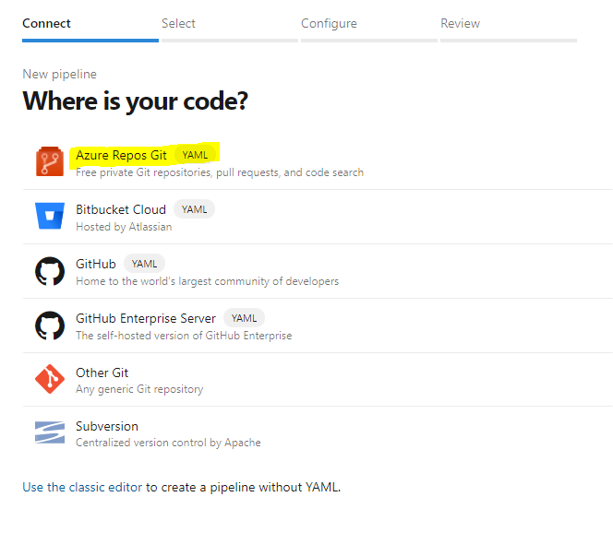

Then the select the new import repository

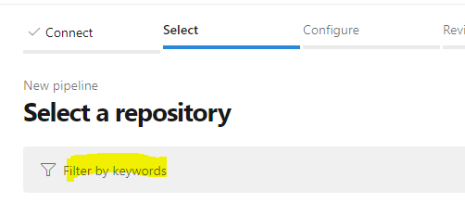

**Configure your pipeline:**

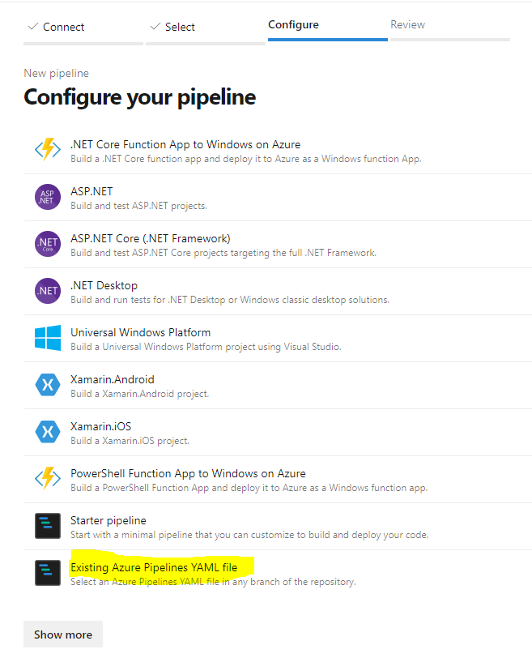

We have our YAML file in the repo, so select “Existing Azure Pipelines YAML file” option

And then select the yml file from the repo

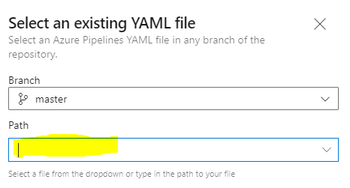

Final step is to review and run the pipeline.

## **2.3 Create a Release Pipeline:**

* Select Releases from the left-hand side tab.

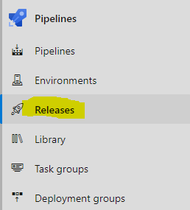

* Click on drop down button next to New button, select New release pipeline.

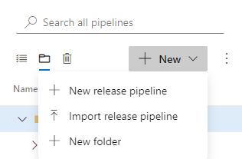

* On Select a template start with an Empty Job
* Name the stage as Dev.

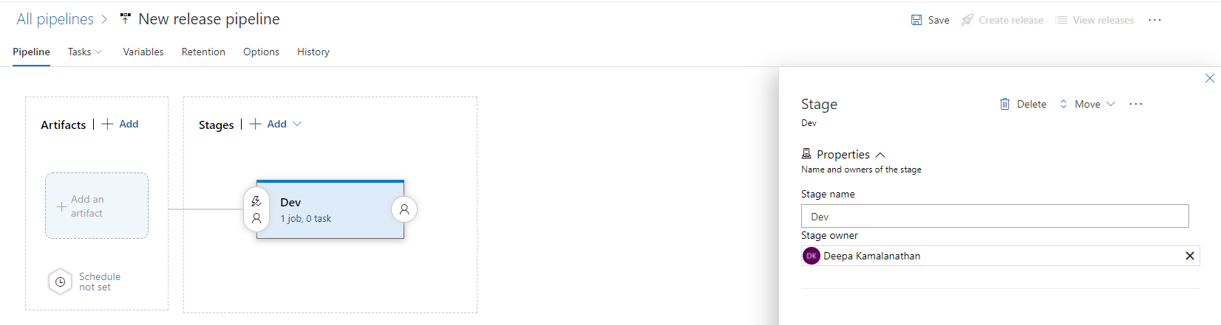

* Click on Add an artifact
* Select the Source type as Build.

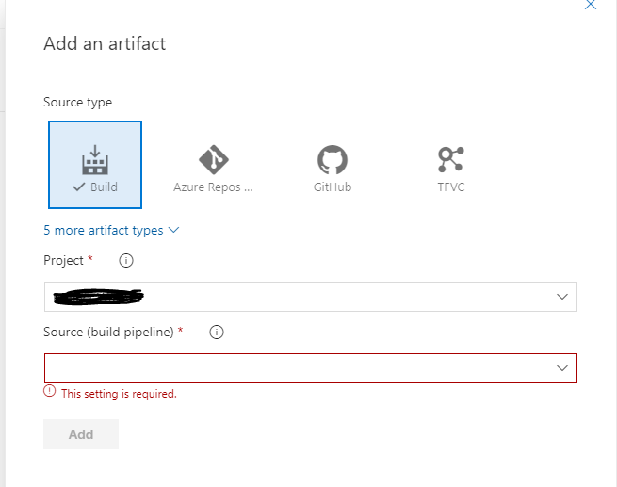

* Select the Source build pipeline from drop down button and click Add button at the bottom.
* Now, Click on the job link in Stage column

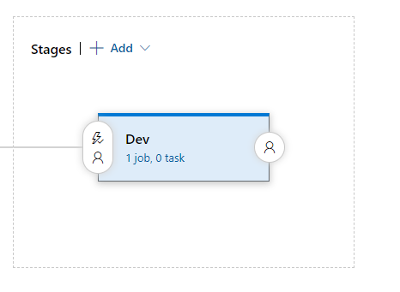

* Check the Agent pool, Agent Specification

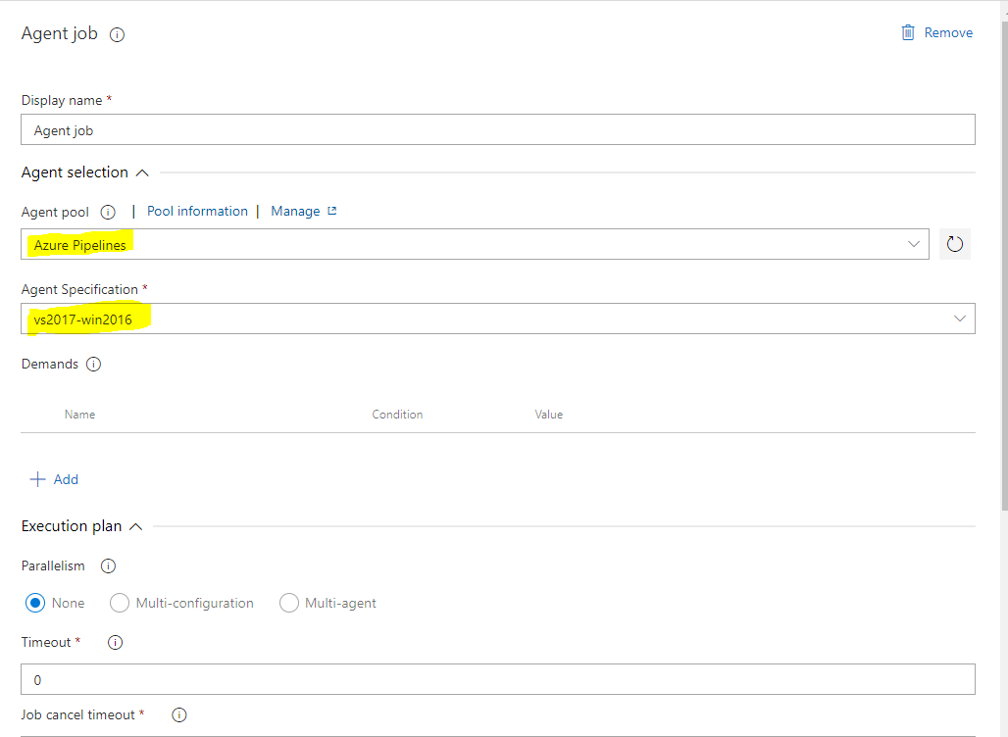

**Adding Task to Agent job:**

* Click on the + symbol to add a new task
* Select Azure Function task and click Add button

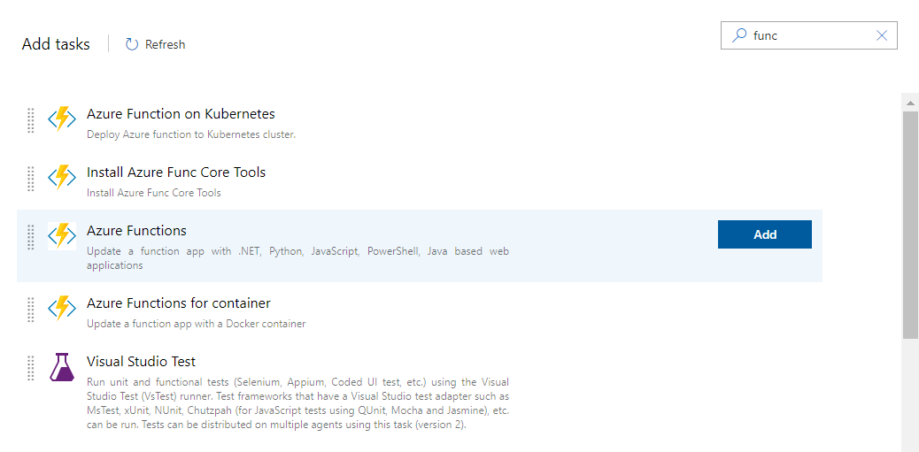

Click on Azure Function App Deploy - To define the Azure function.

* Select the respective Azure Subscription.
* For App Type - Select “Function App on Window” from the drop down.
* Provide Function App name.
* For Package or Folder, select the Function app zip file from drop folder.

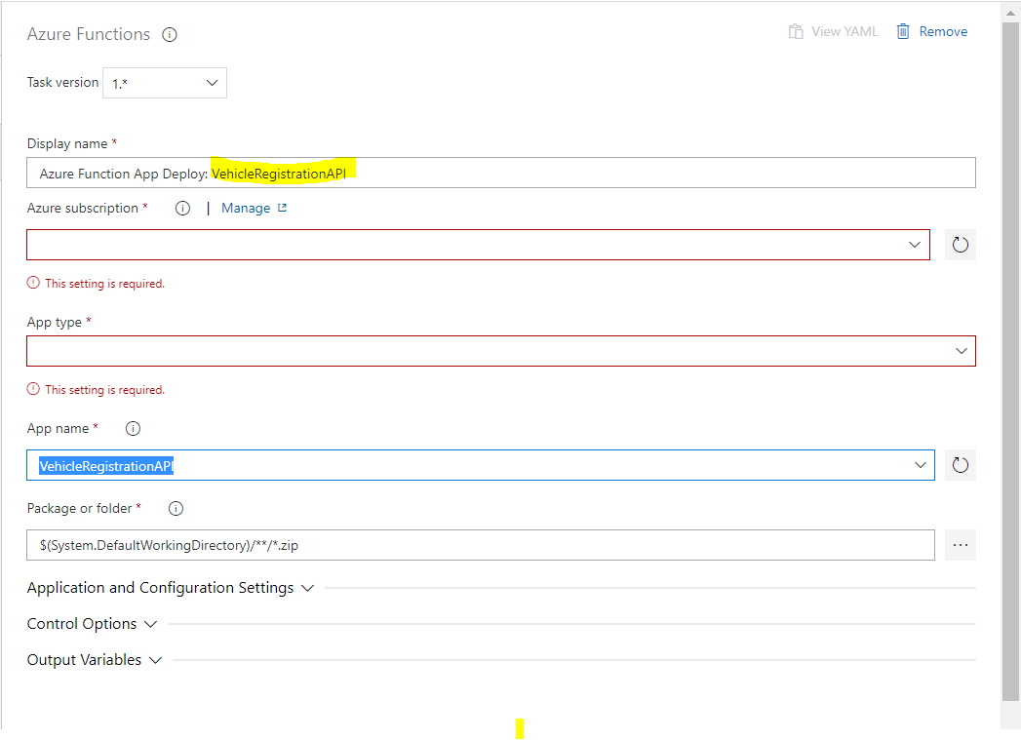

* Rename the New Pipeline name as “VehicleRegistration” and click Save

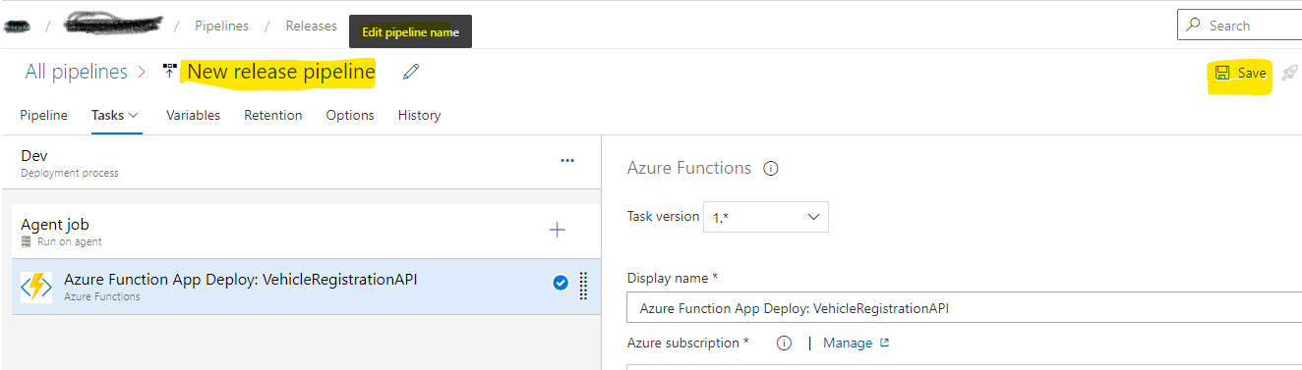

This API doesn’t have “Application and Configuration settings” to be added.

We clone the dev stage and update the respective subscription for Test, UAT and Pre-Prod and Prod.

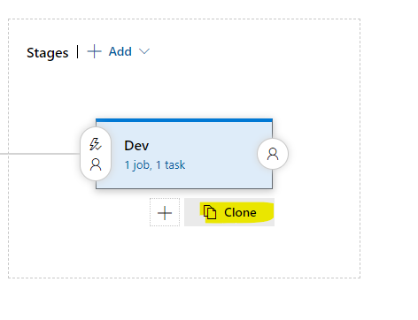

Finally, CI/CD Pipeline should look like

